

Information Security Risk Management Framework

Version: 1.2
Author: CS Risk Management Section
Document Classification: Public
Published Date: May 2018

Document Version History
Effective Date | Review Version # | Changed by | Change Description
DD/MM/YYYY | # | XXXXX | First Version

Review Period
<Insert Period>
Distribution List
- Agency / Organization Management
Document Approvers
Approvers | Signature
Name:  Designation: | Date:
Name:  Designation: | Date:

Table of Contents
Introduction 4
Information Security Risk Management Overview 5
Information Security Risk Management Framework (ISRMF) 5
ISRMF – Processes 6
A. Organizational Goals, Strategy, Governance and Policy 6
B. Legal & Regulatory Requirements 6
C. Enterprise Risk Management (ERM) 6
D. Intelligence & research agencies, incidents, previous risk assessment and geo-political emerging risk reports 6
E. Threat & Vulnerability Management 7
F. Issues Management 7
G. Incident Management 7
H. Tools & Templates 7
I. IS Risk Program Management 8
J. Training & Awareness 8
ISRMF Components 8
A. Risk Governance 8
B. Phases 8
ISRMF Reporting 10
Advice and Support 10


Introduction
The objective of this Information Security Risk Management Framework (ISRMF) is to provide (1) provide assurance to management and stakeholders that critical information security risks are being managed appropriately (2) encourage understanding by management and their staff of the implications of risk exposures (3) enable better business resilience and compliance (4) provide a rigorous decision-making and planning process.

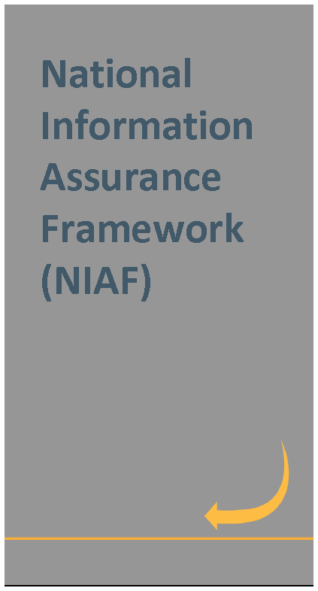
Further, to achieve the objectives of Qatar National Cyber Security Strategy, QCERT has developed this ISRMF. It provides a systematic approach to State Agencies / Organizations to identify, prioritize and manage information security risks and comply with the requirements of National Information Assurance (NIA) policy.

ISRMF provides a structured, yet flexible approach for managing information security risks resulting from the incorporation of information systems into the mission and business processes of State Agency / Organization. This framework is suitable for the State Agency or Organization´s environment, and in particular it aligns with overall enterprise risk management framework (if applicable). Information security risk management framework addresses risks in an effective and timely manner where and when they are needed.

Information Security Risk Management Overview
Information risk management provides an organization a 360-degree holistic view of the risks to its information assets and associated information infrastructure. Information security risk management defines the areas of State Agency / Organization’s information infrastructure and identifies what information to protect and the degree of protection needed to align with the State Agency / Organization’s tolerance for risk. It identifies the business value, business impact, compliance requirements and overall alignment to the State Agency / Organization’s business strategy and National Information Assurance (NIA) policy. Once this information has been identified, it can be presented to the business leadership to make decisions about the level of investment (both financial and resource) that should be utilized to create appropriate information protection and risk management capabilities. After making these decisions, the State Agency Security Manager / information security team can implement the appropriate capabilities to align with the business leadership’s decisions..
Information security risk management is a continual process. It involves establishing an appropriate infrastructure and culture and applying a logical and systematic method of establishing the context, identifying, analyzing, evaluating, prioritizing, treating, monitoring and communicating information security risks associated with any activity, function or process in a way that will enable organizations to minimize losses and maximize gains. This framework describes the overall approach to information security risk management, and it outlines, at a high level, the processes that shall be followed to achieve information security risk management.

Information Security Risk Management Framework (ISRMF)

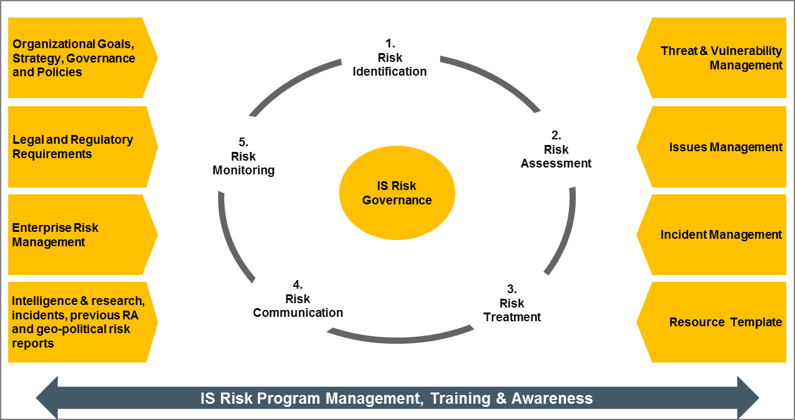

ISRMF – Processes
Processes that support the day-to-day activities of the Information Security Risk Management (ISRM) program with inputs, guiding principles, compliance requirements, supporting information, resources and triggers.

Organizational Goals, Strategy, Governance and Policy
ISRMF aligns with State Agency / Organization’s goals, strategy, governance and policy requirements. It includes
- Alignment of goals and objectives of the ISRM effort with the organizational goals, strategy and governance
- ISRMF complements and takes into account any risk management policy, standard, or requirements the organization has in place; and
- Alignment with Qatar National Cyber Security Strategy, Qatar National Information Assurance (NIA) Framework, ISO/IEC 27005:2011 and ISO 31000 standard and other information security related frameworks / activities

Legal & Regulatory Requirements
ISRMF incorporates Qatar government laws and regulations that directly or indirectly require State Agency / Organization’s to conduct information security risk assessment periodically. It includes compliance with
- Qatar National Cyber Security Strategy
- National Information Assurance Framework (NIAF) which includes the following:
- National Information Assurance Policy
- National Information Classification Policy
- Critical information infrastructure protection law (CIIP)
- Data & privacy protection law; and
- Cybercrime law

Enterprise Risk Management (ERM)
Enterprise Risk Management enables senior management to fully understand the inherent corporate risks including information security risks that their agency / organization face. ISRMF aligns with State Agency / Organization’s ERM framework requirements (if applicable). It includes:
- Alignment of ISRMF with ERM framework and ISO 31000 standard
- Alignment of Information Security (IS) risk organization structure with enterprise risk organization structure
- Alignment of IS risk practices to the enterprise risk practices
- Enabling State Agency / Organization’s independent assurance function to review ISRM; and
- Incorporating inputs from ERM to information security risk management program

Intelligence & research agencies, incidents, previous risk assessment and geo-political emerging risk reports
ISRMF manages current and emerging threats and risks pertaining to State Agency / Organizations’ through obtaining input / guidance from:
- Intelligence agencies (for example, QCERT, Qatar National Risk / Threat Indicators, Qatar government Security Operations Center, etc..)
- Mass media, particularly web-based research resources such as SecurityFocus.com, SecurityWatch.com, SecurityPortal.com, and SANS.org and geo-political / statistical emerging risks report
- Input from previous risk assessment documentation
- Information system’s audit reports, system anomaly reports, security review reports, and system test and evaluation reports
- Vendor advisories
- Vulnerability lists, such as the NIST I-CAT vulnerability database (http://icat.nist.gov); and
- Incident/emergency response teams and post lists (e.g., SecurityFocus.com forum mailings)

Threat & Vulnerability Management
ISRMF threat and vulnerability management process include three major elements:
- Information Asset Management – identification of information assets and asset valuation based on confidentiality, integrity and availability
- Threat and vulnerability analysis – an exercise that models a particular information asset or business process against attack scenarios and known vulnerabilities to evaluate its resiliency or capability to repel attacks; and
- Vulnerability management – uses the input from the threat and vulnerability analysis to mitigate the risk that has been posed by the identified threats and vulnerabilities (controls and metrics)

Issues Management
Issues Management process addresses issue coordination, tracking, facilitation of remediation coordination, and escalating of issues related to information security risk. Issues can be derived from a variety of sources including audits, regulatory compliance, risk assessments, security reviews, questionnaires, monitoring, ticketing system (helpdesk tool), etc... The activities associated with this process include:
- Facilitation of the issues documenting process (tracking, monitoring, and reporting)
- Facilitation of the risk acceptance process
- Facilitation of tracking and reporting on the status of issues (Integration into Monitoring and Reporting phase); and
- Providing or facilitating guidance on potential solutions to mitigate issues

Incident Management
Incidents management process helps to identify emerging threats and assess the likelihood / impact of existing and new threats. It involves:
- Assessment of the possible sources of security incidents and the possible likelihood that a security incident of a particular type will happen - review of the
- history of system break-ins
- security violation reports
- incident reports; and
- Assistance with risk treatment - establishing an incident response capability to prepare for, recognize, report, and respond to the incident and return the IT system to operational status

Tools & Templates
Tools and templates optimize information security risk management processes and benchmarking reporting for State Agencies / Organizations. ISRMF tools and templates drive efficiencies into the information security risk management processes, while providing the business a more defined view into IS risk. Tools and templates developed as part of the ISRMF include:
- Information security risk management policy template
- Information security risk management procedure
- Information security risk register
- ISRMF process flow
- Information security risk management roles and responsibilities matrix
- Information security risk management checklist
- ISMRF management report template
- ISRMF management approval template; and
- ISRM management training and workshop document

IS Risk Program Management
ISRMF Program Management function is responsible for the centralized, coordinated management of ISRM program to achieve tactical and strategic objectives and goals. This function is responsible for planning, organizing, staffing, controlling, and leading the ISRM program. IS risk program management process aligns with the organization program management function. The activities associated with this process include:
- Delivering a risk management program from concept through implementation
- Ensuring risk management program is properly budgeted, and completed under or at budget projection; and
- Ensuring proper resource allocation and availability for risk management program

Training & Awareness
Training and awareness is responsible for the content associated with the education and awareness of ISRMF, policies, standards, risk processes and risk management responsibilities. It includes actual training and delivery of the content, or work with business unit liaisons who in turn will deliver the material in their own awareness or training campaigns. The activities associated with this process include:`
- Providing information security risk training and education
- Managing a communication program to promote ISRM activities and new risk topics
- Ensuring employee attestation of compliance or adherence to ISRM policies
- Liaising with training coordinators within other business areas; and
- Tracking and reporting on education and awareness compliance activities

ISRMF Components
Processes that constitute the life cycle of the ISRM program. Detailed step-by-step procedure to implement the ISRMF has been provided in the Information Security Risk Management Procedure (ISRMP)

Risk Governance
Risk Governance refers to defining the overall context for ISRM. It includes:
- Formalization of risk governance steering committee, roles and accountabilities, policy and procedure
- Definition of scope and boundaries of the ISRM
- Definition of IS risk assessment criteria (evaluation, acceptance etc..); and
- Coordination of IT/IS implications and regulatory requirements with appropriate corporate and external bodies

Phases

Risk Identification
Risk identification involves the identification of threats, vulnerabilities and risk sources, events, their causes and their potential consequences. It includes:
- Identification of sources of potential threats, vulnerabilities and risks, areas of impacts, events (including changes in circumstances), their causes and their potential consequences; and
- Generation of a comprehensive list of threats, vulnerabilities and risks based on those events that might create, enhance, prevent, degrade, accelerate or delay the achievement of objectives

Risk Assessment
  - Risk Analysis
Risk analysis is used to understand the nature, sources, and causes of the identified risks and to estimate the level of risk. It is also used to study impacts and consequences and to examine the controls that currently exist. Risk analysis involves:
- Risk analysis can be qualitative, semi-quantitative or quantitative, or a combination of these, depending on the circumstances/ requirements
- Analysis of the most probable threats to an organization and its likelihood
- Analysis of the related vulnerabilities of the organization to these threats
- Analysis of existing and planned control strength to reduce the risk
- Risk analysis provides the basis for risk evaluation and decisions about risk treatment
2.2 Risk Evaluation
Risk evaluation is the process of comparing the estimated risk against given risk criteria to determine the significance of risk. The purpose of risk evaluation is to make decisions, based on the outcomes of risk analysis, about which risks need treatment and treatment priorities. It includes:
- Alignment of information asset evaluation criteria with National Information Classification policy [IAP-NAT-DCLS] Appendix B – Asset Classification Model
- Comparison of risk analysis results with risk criteria in order to determine whether or not a specified level of risk is acceptable or tolerable
- Calculation of inherent risk value without considering existing controls and intermediate residual risk after considering existing controls
- Assistance in risk treatment decision process through prioritizing the estimated levels of risks

Risk Treatment
Risk treatment involves prioritizing risks, selecting one or more options for modifying/ avoiding / sharing / retaining risks, and implementing those options. Once implemented, treatments provide or modify the controls. Risk treatment involves:
- Definition of risk treatment plan which clearly identifies the priority ordering in which individual risk treatments should be implemented and their timeframes
- Prioritization could be established using various techniques like risk ranking and cost benefit analysis
- Selection of appropriate risk treatment options which includes modification, avoidance, sharing and retention
- Assessment of risk treatment plan and effectiveness of that treatment
- Deciding whether consequent residual risk levels are tolerable
- If not tolerable, generating a new risk treatment; and
- Alignment of risk treatment option with Qatar National Standards

Risk Communication
Risk communication is an activity to achieve agreement on how to manage risks by exchanging and/or sharing information about risk between the decision-makers and other stakeholders. The information includes, but is not limited to the existence, nature, form, likelihood, severity, treatment, and acceptability of risks. Risk communication involves:
- Consulting with stakeholders to gain input into identifying and evaluating vulnerabilities, threats, controls inherent risks, initial residual risks and residual risks
- Dash boarding and reporting of risk management results to management (Board, Audit Committee, Regulatory Bodies, etc…)

Risk Monitoring
Risk monitoring includes the evaluation and monitoring of performance to determine whether the implemented information security risk management options achieved the stated goals and objectives. The activities associated with this process include:
- Continuous monitoring of the IS environment and emerging risks
- Analysis of IS risk metrics and reporting needs
- Facilitation and management of metrics and reporting implementation; and
- Monitoring and reporting of emerging risks to management

ISRMF Reporting
Information security risk management results shall be shared with QCERT team in accordance with the requirements of National Information Assurance Framework (NIAF).

Advice and Support
Advice and support in relation to ISRMF is available by consulting QCERT team.

